**Multimedia Systems**

**Assignment-01**

G.I.F file header analysis:-



S20220010207  
[Srikar Chaturvedula](mailto:srikarchaturvedula@gmail.com)

### I have chosen the GIF file mentioned above from an internet source and ran the ***‘od’*** commands mentioned in the class

In the directory of the GIF file i have run the commands  
***od -c ms.gif | head -2***

***od -x ms.gif | head -2***

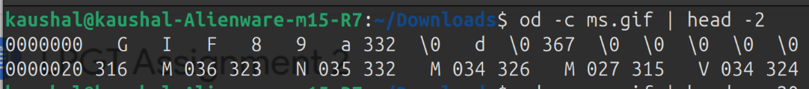

LETS analyse the above output and understand

od -c ms.gif | head -n 20

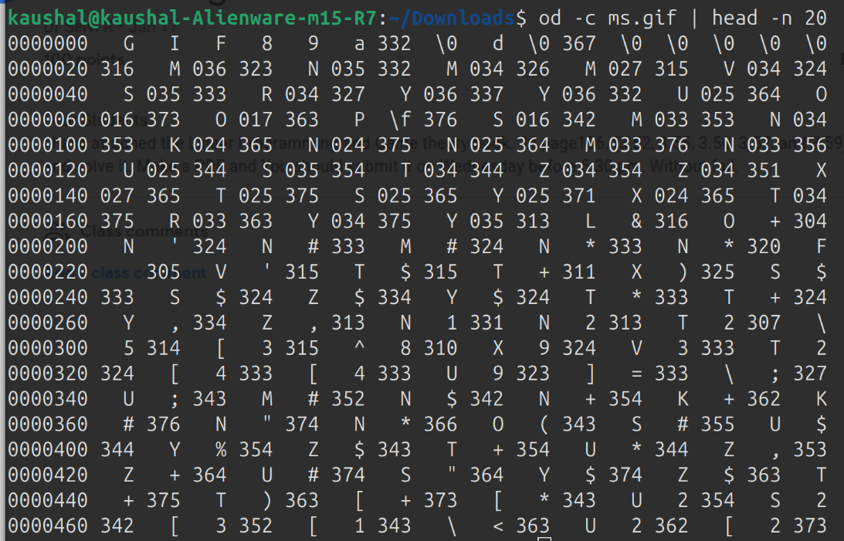

Understanding GIF File Structure Using od Command

1. **Introduction:**The od -c command helps inspect the contents of a GIF file in a readable format. This allows us to analyze different sections of the file, including the GIF header, screen descriptor, color lookup table, and image data.

Command used:od -c ms.gif | head -n 20

This extracts the first 320 bytes, which is enough to analyze key components.

1. **GIF File Structure:**

| Section | Bytes | Purpose |
| --- | --- | --- |
| GIF Header | 6 | Identifies file format (GIF 87a or 89a) |
| Logical Screen Descriptor | 7 | Defines screen size and color table details |
| Global Color Table (GCT) | 3 × 2^(Size+1) | Stores predefined colors |
| Image Descriptor | 10 | Marks the start of image data |
| Raster Data (Compressed) | changes | Encodes image pixels |

1. **Explanation of GIF Header Sections:**

GIF HEADER:- "89a" means it is a GIF 89a version.

Logical Screen Descriptor:-

* Screen Width: 332 pixels
* Screen Height: 100 pixels
* Packed Field: 0xF7
* Background Color Index: 0x00
* Pixel Aspect Ratio: 0x00

Global Color Table (GCT):-

0xF7-> 11110**111**

Last 3 bits 111 -> value is 7

**Size of GCT=3×2(Size+1)**,For above gif i have taken Size = 7:

=3×256=768 bytes

The table stores 256 colors, each using 3 bytes (RGB).

1. **Required Data and Lines in od -c:**

| Section | Bytes | Lines in od -c |
| --- | --- | --- |
| GIF Header | 6 | 1 |
| Logical Screen Descriptor | 7 | 1 |
| Global Color Table (GCT) | 768 | 48 |
| Image Descriptor | 10 | 1 |

Analyzing a GIF file using od -c helps in understanding its structure, including the header, screen descriptor, color table, and image data. The GIF 89a format supports a global color table, which in this case consists of 256 colors stored in 768 bytes. The image data is compressed using the LZW algorithm. By capturing around 50 lines of output, we can examine all essential sections of the file.